Born Self-Actualized / Born Healthy and Whole

Mike Sosteric
Date: 2018-1-4
Source: Lighting Path (Medium)
Version: 0.80
URL:

Born Self-Actualized / Born Healthy and Whole
There is a very common conception among the various cultures of this world that human bodies and human souls start out infantile, weak, and undeveloped and that over time, through adaptability, hard work, and tough life lessons, they grow, develop, self-actualize, attain enlightenment, get rich, and graduate onto some higher level. It is in esoteric and exoteric religious traditions (e.g., Christianity, Masonary, Gnosticism, etc.). You even find it in popular culture, as for example in Star Wars where Jedi knights disappear upon death and ascend into some higher state of being to become “force ghosts.”

The Big Life Journey Ideology: Colonial Mythology
We might call this the Big Life Journey (BLJ) view of human existence.
Both theists and a-theists, materialists and spiritualists, rich and poor, see the human species this way. They just use different language. The spiritually minded see this BLJ as some sort of ascent towards heaven. The scientifically minded as some kind of march towards an evolutionary pinnacle of adaptive perfection. The spiritually minded see success as ascension into heaven or graduation to a higher level. The materialist as successful species (or genetics-linked class) survival.
Both see dialectical struggle between light and dark forces as the primary motor of this advance.

Eupsychian Theory: Born Healthy and Whole
But this is not the only way to look at it. There is an alternative, common in pre-European (i.e., pre-colonial) Indigenous world views, that asserts that we aren’t born “tabula rasa” but are instead born “into the clan as a whole person.” (Kapisi et al., 2022). In this view, we come into this world a fully formed and fully self-actualized being (albeit in an undeveloped body), a full person, as Elder Roy Bear says (Elder Roy Bear in Kapisi et al., 2022). Our fully actualized being, our Spiritual Ego if you like, enters into the body (the Physical Unit) which must then be nurtured if it is to properly grow.
Here, completion is granted at birth.
Here, the only thing you have to do is become who you already.
Practical Implications for Parenting and Education
You have to admit, this is a much different way of looking at humans and their potential than the common European view. Just how different it is becomes obvious when you unwind the different implications for human health and human development.

BLJ vs Whole-at-Birth Model
Dimension | Big Life Journey (BLJ) | Whole-at-Birth Model
Ontology | Blank/Sinful/Primitive | Whole, Pure, Fully Formed
Education | Indoctrination, Discipline | Supportive, Observational
Socialization | Training for Labor | Facilitation of Full Expression
Institutions | Hierarchical, Controlling | Participatory, Nurturing
Spirituality | Ascensionist, Merit-Based | Presence-Based, Grounded
Development | Scarcity + Competition | Abundance + Cooperation

For example, in the European view you are born, depending on who you talk to, as either blank, sinful, or primitive. Consequently, you have to beaten (sometimes gently, sometimes not so much) into an acceptable shape. These beatings will involved forced attendance at school, forced curriculum, force compliance with routinized schedules and authority, and so on and so forth. All this indoctrination and discipline is given existentially acceptability by the assertion that you are are a blank slate or sinful/karmic reprobate and you need to be filled in and straightened out.
On the other hand, if you accept that humans are born whole, then you don’t need school or churches or priests or teachers or even parents to impose, control, or mold, you need them to be observers and facilitators who recognize and support unfolding potential. In this view, all you need from the agents of socialization in your life (parents, teachers, priests, employers, etc.) is support so you can fully realize who you already are.
In this view, parents and teachers need to observe children, figure out who they are, and help them realize their full self.
Here, society needs to support you on a journey not towards wage-slavery but on a journey towards developmental fullness.
It’s not that hard.
You don’t need advanced degrees in psychology to figure this out.
The Garden Metaphor: A Healing Developmental Model
If you want to grow a garden with the prettiest flowers, you don’t impose or harass. You don’t demand your roses look like carnations. You provide structure, guidance, and support; you meet the garden’s need for water, food, and safety. You periodically weed. Other than that, you let the garden grow into itself. That’ s all there is to it. That’s all required to achieve full fruition. Just meet the garden’s needs.
It’s the same with humans.
If you want humans to grow into full potential, don’t impose, shape, and train; instead, create the right environmental conditions for them; meet all their needs. Given them proper social, economic, political, and spiritual supports. Don’t worry about them so much. The development will take care of itself.
Revolutionary Possibility: Towards a Needs-Based Society
I realize that some may balk at this point, but there’s no reason to think this might not be true, that humans might be born fully formed beings and that all they need is to have all their needs met and they’ll grow up just fine.
And if it is true, if we are born fully whole, what might things look like if we had a society that met all our needs?
It is an interesting question.
Other than some ancient intimations in the spiritual corpus of this planet, we don't know because we’ve never created a society whose sole purpose is to meet its citizens needs (though if accounts by Western observers in China are true, China seems to be getting close). All we have is 10,000 years of rich people exploiting poor people (Sosteric, 2016) in societies arguably designed to undermine human development in the service of unfettered accumulation of wealth (Sosteric, 2018).
[https://www.youtube.com/watch?v=opwUrGVc8dA&t=8s]
However, if we did create such a society, I think humans would be a lot different than they are now. I would theorize that if fully supported in their development and not shaped into worker bees, humans would be a smarter, stronger, more creative, connected, and empathic than they are now. More like the philosophical and spiritual ideals some traditions point to.
Research into human potential in optimal conditions supports this, suggesting that when basic needs are securely met, traits like intrinsic motivation, curiosity, and compassionate social engagement come to the fore (Deci & Ryan, n.d.).
I think societies, built up as they would be by the talents and wisdom of fully realized human beings, would be a lot different too
It’s not a weird thing to talk about.
There’s been discussions.
Psychologist Abraham Maslow coined the term “Eupsychia” for a “good society” that would do be focused on meeting essential human needs (Maslow, 1961). He even theorized a management structure that would support that (Maslow, 1965). There is also a thin modern thread of ongoing discussion (Hoffman, 2023) that keeps the idea (barely) alive.
I hope you can see, it is definitely something worth talking about, especially now as we stand at the increasingly obvious end of modern civilizations.
Of course, humans have a more complicated set of needs than flowers and meeting them all is a lot harder than planting and nurturing a garden.
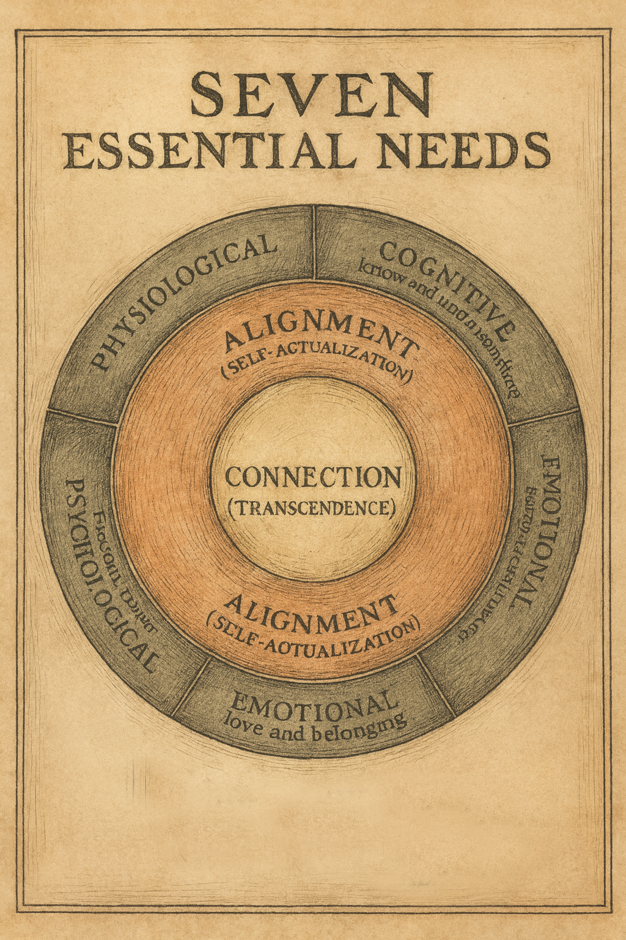
We theorize a Circle of Seven Essential needs, with an exterior ring of basic needs and two inner rings for alignment and connection (Sosteric & Ratkovic, 2022). Meet these rather extensive set of needs and humans will naturally grow up bright and powerful lights. Thwart or undermine satisfaction in any way, and you become less than you truly could be, just like a flower in a garden that isn’t tended to, nurtured, and supported.
So, what does this mean for us, right now?
In the not-too-distant past, this discussion would have been theoretical. Even thirty years ago, human technological, administrative, communication, and socialization systems where simply not advanced enough to achieve global needs satisfaction, but they are now. With the advent of AI, it would be easy to create the global conditions necessary for immediate utopian renewal. The only problem is the death-lock the accumulating class seems to have on all our advanced global systems.
But they can be removed and everything can change over night. It’s happened before. It will happen again. Their grip is crumbling. It is only a matter of time.
So what are we going to do?
I guess at this point, you have a choice.
You can continue to view the world through a Colonial/European lens that views humans as undeveloped lumps of clay on some kind graduated evolutionary/spiritual assent, or you can try on a different view and initiate different practices, one that sees humans as born fully formed and just needing needs met to achieve full potential.
Current systems are failing.
Current leaders are insane.
Planet ecology is in full scale collapse.
Seriously, you have nothing to lose and everything to gain.
Take a fashion risk.
If you do decide to move forward, then great, let’s get started.
It’s not hard.
Here is what you have to do.
- Step 1: Dismantle ideological distortions (via education, SpiritWiki, etc.).
- Step 2: Create localized needs-supportive environments.
- Step 3: Implement global frameworks of care (AI, policy, community).
We will talk about each of these things and more as we transform our systems and built a new world.

Deci, E. L., & Ryan, R. M. (n.d.). The “What” and “Why” of Goal Pursuits: Human Needs and the Self-Determination of Behavior. Psychological Inquiry, 11(4), 227–268. https://doi.org/10.1207/S15327965PLI1104_01
Kapisi, E. R. B. C.-O., Choate, P., & Lindstrom, G. (2022). Reconsidering Maslow and the hierarchy of needs from a First Nations’ perspective. Aotearoa New Zealand Social Work, 34(2), Article 2. https://doi.org/10.11157/anzswj-vol34iss2id959
Sosteric, M. (2016). Rocket Scientists’ Guide to Money and the Economy. Lightning Path. https://www.patreon.com/posts/lp-workbooks-and-91290808
Sosteric, M. (2018). How money is destroying the world. The Conversation. https://theconversation.com/how-money-is-destroying-the-world-96517

